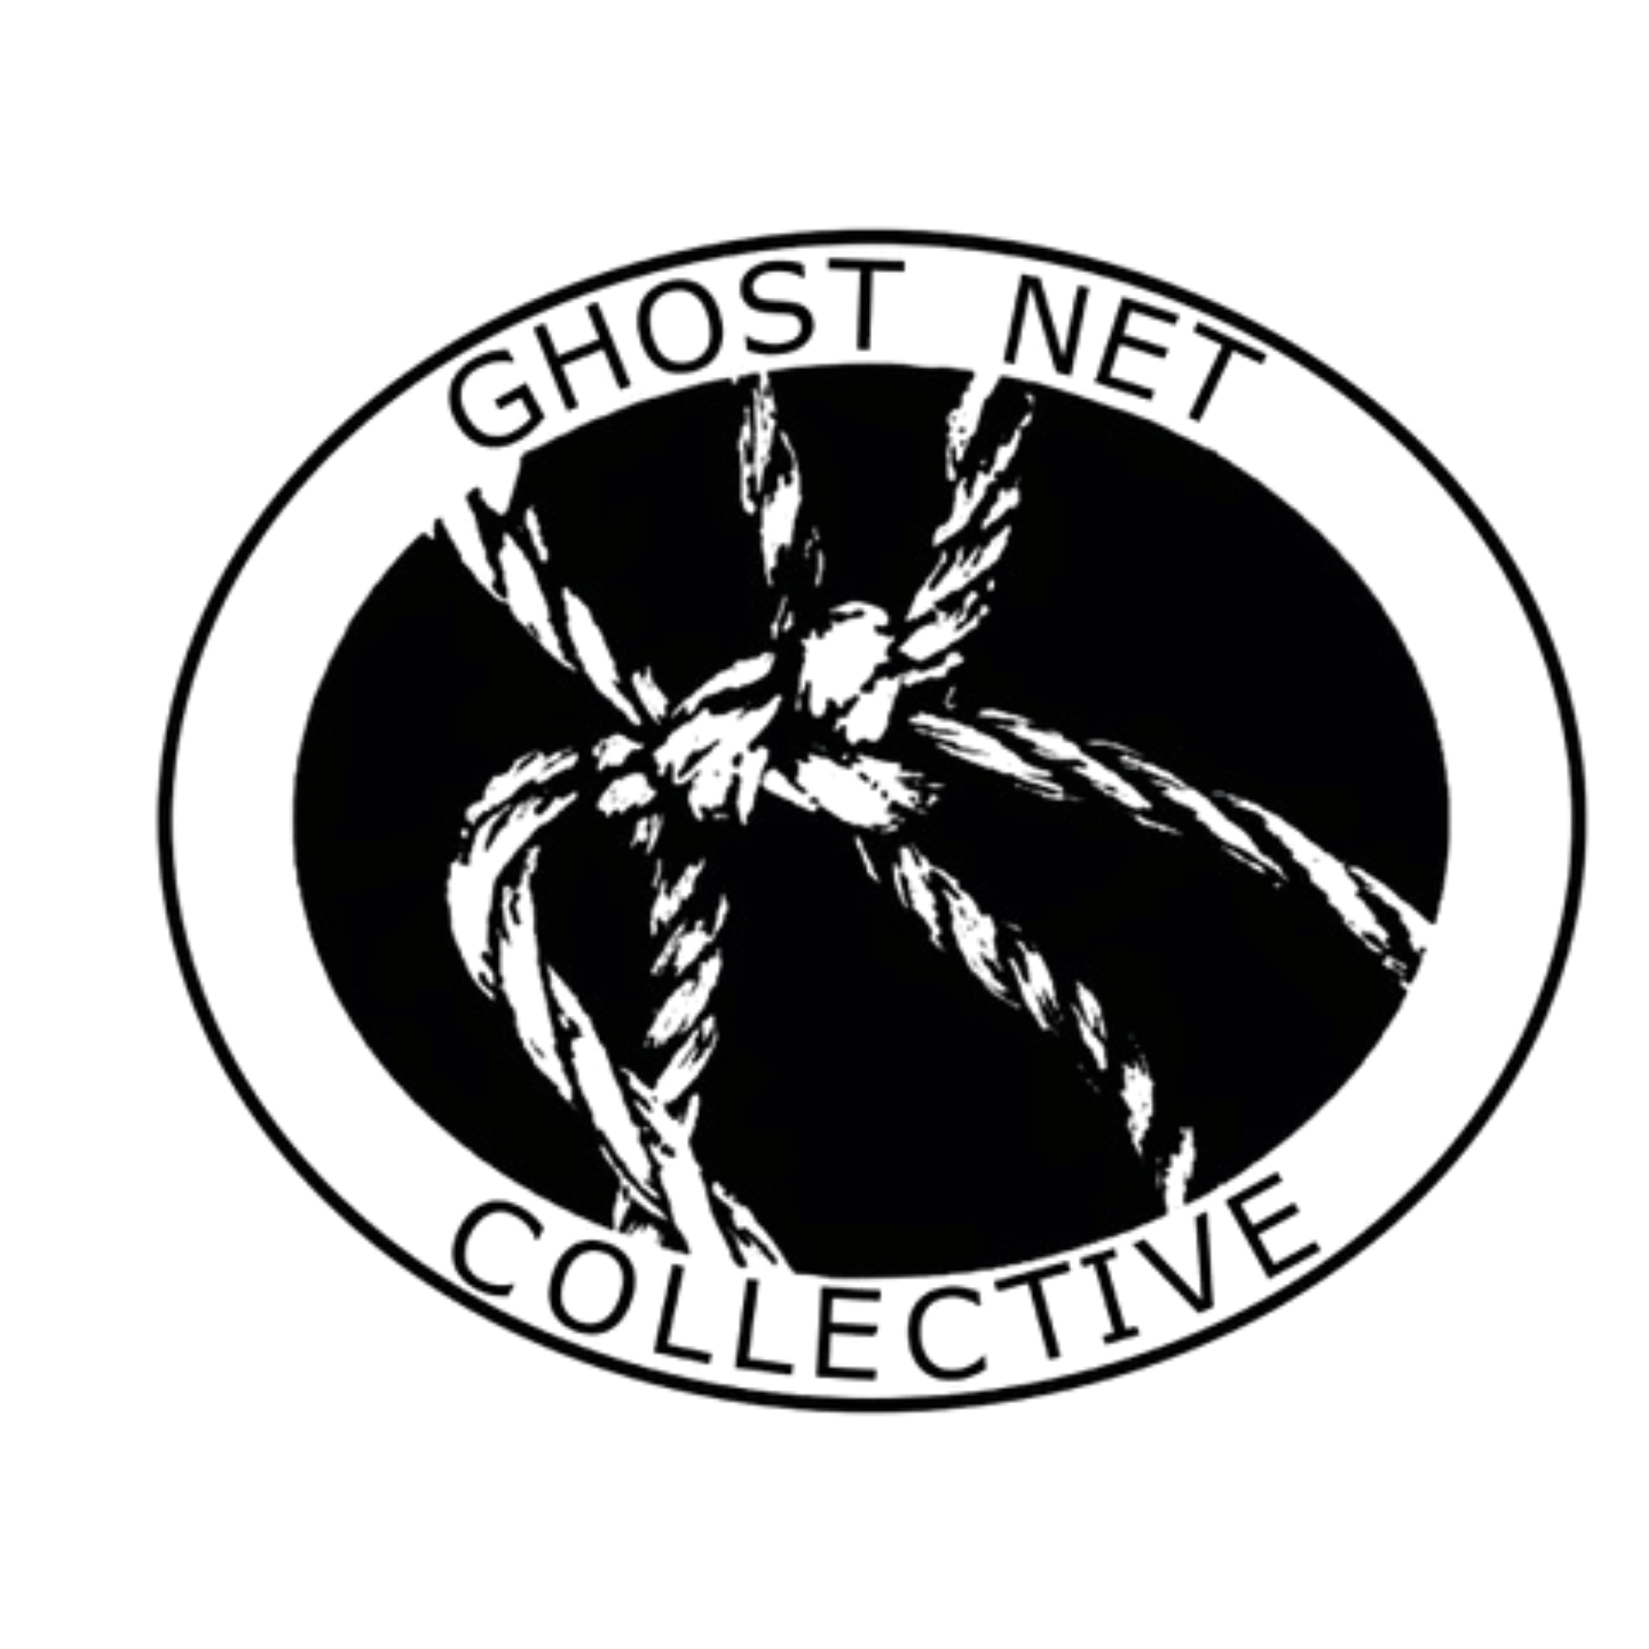
1 April 2026
Reef Guardian Schools - Capricorn Coast
Dear Principals and Teachers,
We are pleased to invite your Science and Arts teaching staff to participate in the Keppel Island Marine Debris Educator Field Workshop, a fully funded professional learning opportunity delivered by Capricorn Coast Marine Community.
This initiative is proudly supported by the Queensland Government through the Engaging Science Grant Program, ensuring there is no cost to participating schools.
This facilitator-led, field-based workshop focuses on ghost nets, marine debris, and key threats to marine turtles, including fishing line entanglement, boat strikes, strandings, disease, freshwater runoff, and plastics. The program incorporates citizen science and creative reuse, supporting cross-curricular delivery across Science, STEM, Sustainability, and the Arts.
Participating teachers will receive curriculum-aligned, classroom-ready resources, along with ongoing phone and/or Zoom support following the workshop.
The program includes:
- Marine debris and marine turtle conservation presentation
- Field investigation and citizen science methodologies
- Marine Stranding Officer guest presentation
- Cultural perspectives on Sea Country
- Safe handling, sorting, and cleaning of net and rope
- Demonstration of creative construction techniques
- Small turtle build activity and collaborative life-size turtle group task

As part of the Engaging Science Grant objectives, participating teachers are expected to integrate the workshop content into their Term 3 curriculum or teaching program. Capricorn Coast Marine Community will support and document these outcomes through data collection, participation in selected school activities (where appropriate), and photographic documentation (with school permissions).
We can also provide a life-sized display turtle for school visits to support student learning about marine debris, fishing line impacts, boat strikes, strandings, and other key risks facing marine turtles and the marine environment.
Places are limited to approximately 30 teachers across the region. We would greatly appreciate your support in sharing this opportunity with your Head of Science, Head of Arts, and relevant teaching staff.
Please see the attached flyer for further details.
Please contact us if you require additional information or wish to discuss participation.
Yours sincerely,
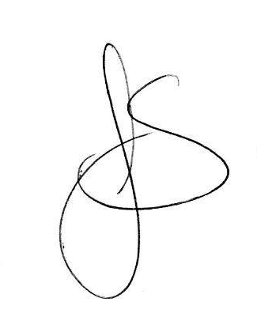
Jo Stoyel
Chair
Capricorn Coast Marine Community
capcoastturtlerehab@gmail.com
0408 873 047

