




REEF GUARDIAN CHAMPION AWARD

PRESENTED TO

Student Name Here

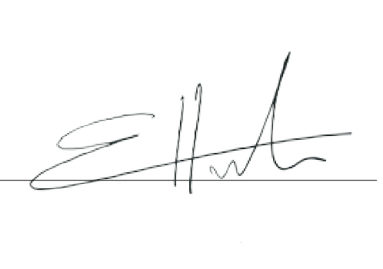
In recognition of your passion and continued commitment to Care, Learn Act, Share as a Steward of the reef who inspires change across generations.
Day Month Year here
REEFED.EDU.AU
DATE OF CERTIFICATION
ELIZABETH HICKMAN
Reef Authority

