Southern Cross Catholic College – Student artwork incorporating single use materials.
From students in years 1 and 4.
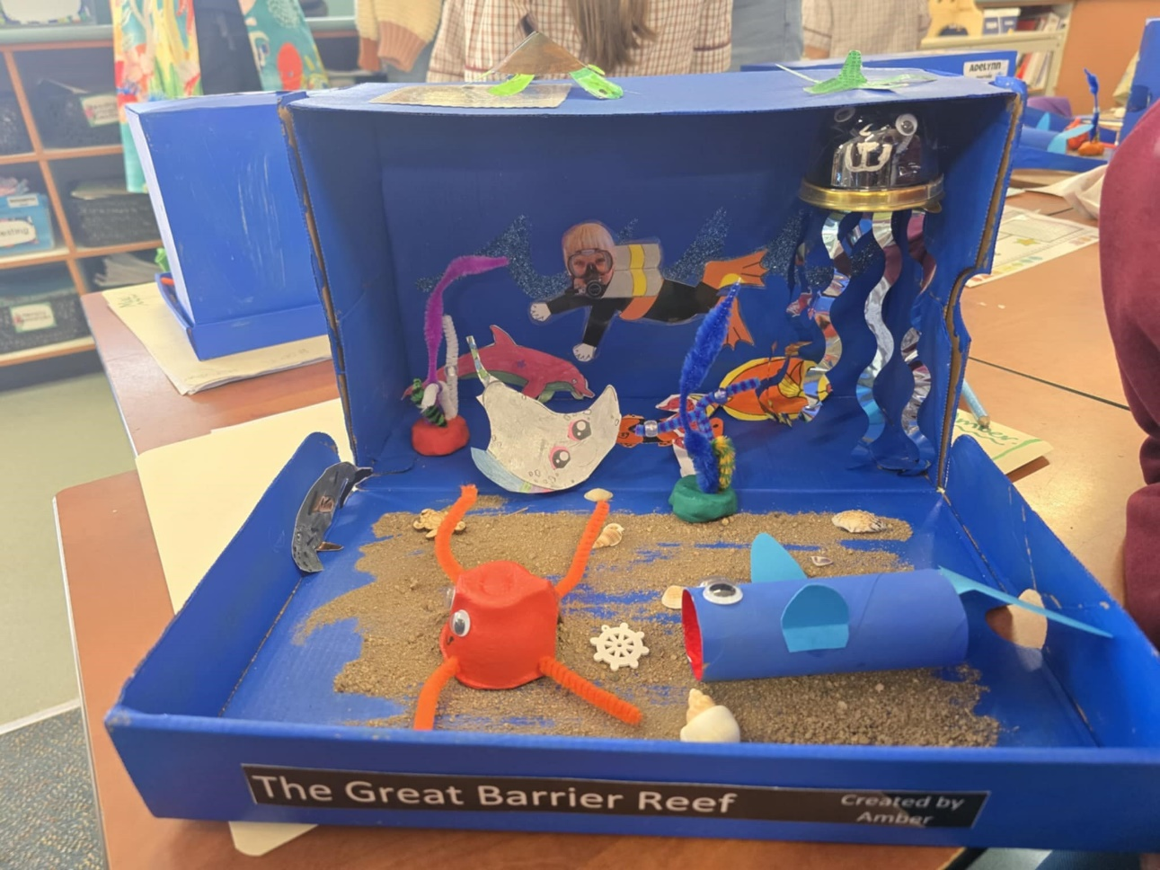
Reef diorama
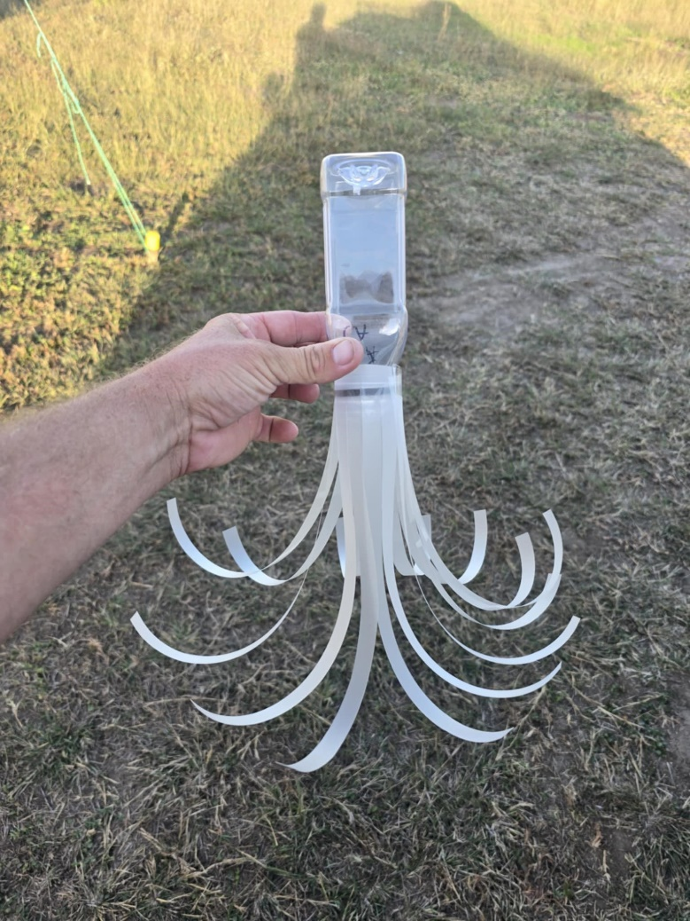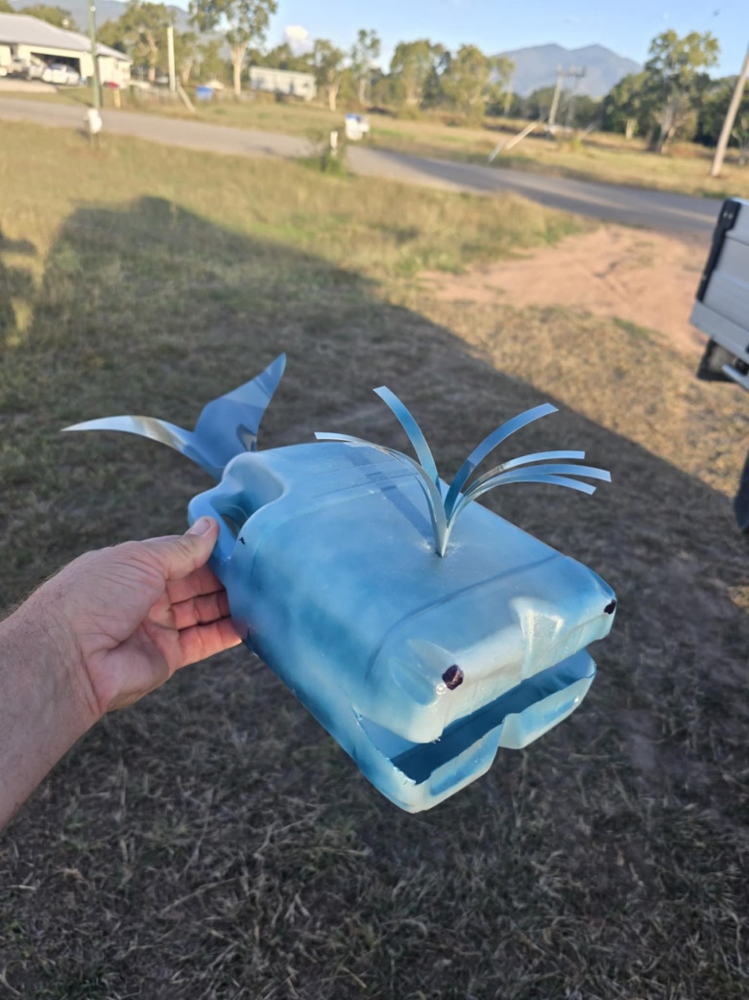
Jellyfish Whale

