RAPID MONITORING - BE A MARINE BIOLOGIST FOR A DAY – TIMED SWIM (10 MINUTES)
ANIMALS | TALLY | TOTAL | ANIMALS | SIZE |  | TALLY | TOTAL
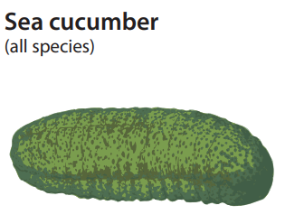 |  |  | 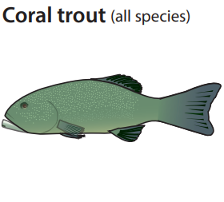 | <38cm
 |  |  |  | >38cm
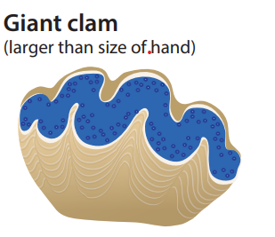 |  |  | 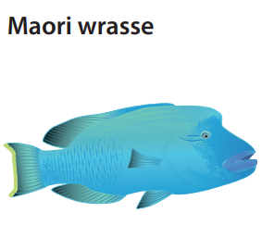 | SEX |  | TALLY | TOTAL
 |  |  |  | Male
 |  |  |  | Female
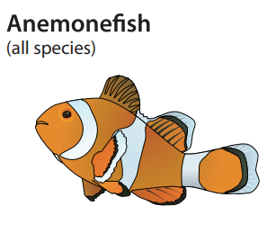 |  |  | 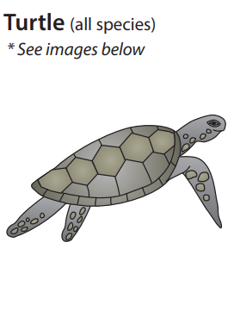 | TYPE |  | TALLY | TOTAL
 |  |  |  | Green Turtle
 |  |  |  | Hawksbill Turtle
 |  |  |  | Other (please name)
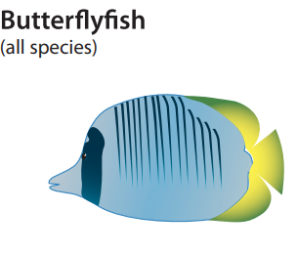 |  |  | 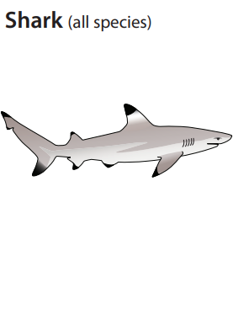 | TYPE |  | TALLY | TOTAL
 |  |  |  | Whitetip reef shark
 |  |  |  | Blacktip reef shark
 |  |  |  | Other (please name)
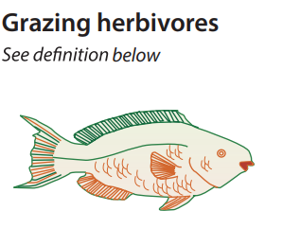 |  |  | 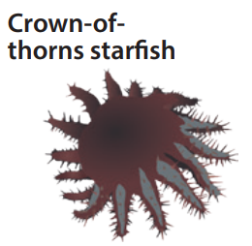 | SIZE |  | TALLY | TOTAL
 |  |  |  | Juvenile
 |  |  |  | Adult
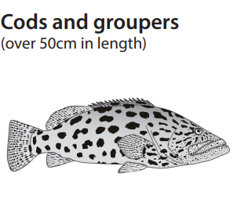 |  |  | Sea Turtles  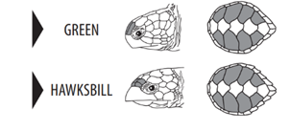 |  | 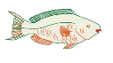  Grazing Herbivores  Look for a school of similar sized fish moving slowly along the reef, foraging and grazing close to the coral reef substrate. The most important types to record are species of parrotfish, surgeonfish, rabbitfish and unicornfish.

